Program Two Part One

//summary This program takes two data points from a user (a x and a y cordinate) and finds the distance between

//these two points.

//name: Jenna Wolf

//class: Fundamentals of Programming, CS155 - 01

//instructor: Dr. Art Kazmierczak

//date: 8/29/2023

import java.util.Scanner; //alowes the user to input data

public class Main

{

public static void main(String[] args) {

Scanner input = new Scanner(System.in);

//holds the data used to perform calculations

double point1x, point1y, point2x, point2y, distance;

//gets the info from the user for point ones x and y and point twos x and y

System.out.println("Please enter your x cordinate for point one: ");

point1x = input.nextDouble();

System.out.println("Please enter your y cordinate for point one: ");

point1y = input.nextDouble();

System.out.println("Please enter your x cordinate for point two: ");

point2x = input.nextDouble();

System.out.println("Please enter your y cordinate for point two: ");

point2y = input.nextDouble();

//performs the distance calculation

distance = Math.pow(Math.pow((point2x - point1x), 2) + Math.pow((point2y - point1y), 2),0.5);

//outputs the distance between the two points entered

System.out.println("The distance between your two points is: " + distance);

}

}

Output:

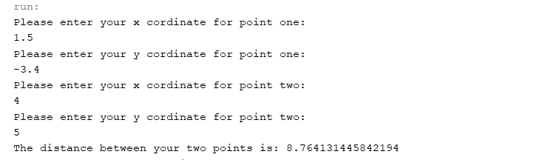

Program Two Part Two

//summary This program takes in the farenheit and the wind speed from the user and finds the wind chill using that data

//name: Jenna Wolf

//class: Fundamentals of Programming, CS155 - 01

//instructor: Dr. Art Kazmierczak

//date: 8/29/2023

import java.util.Scanner; //alowes the user to input data

public class Main

{

public static void main(String[] args) {

Scanner input = new Scanner(System.in);

double far, wind, v, chill; //holds the data used to perform calculations

//gets the info from the user about the farenheit and the wind speed

System.out.println("Enter a temperature between -58 and 41 degrees farenheit: ");

far = input.nextDouble();

System.out.println("Enter the wind speed (>= 2) in miles per hour: ");

wind = input.nextDouble();

//finds the velocity of the wind

v = Math.pow(wind, 0.16);

//caculates the wind chill

chill = 35.74 + (0.6215 \* far) - (35.75 \* v) + (0.4275 \* far \* v);

//outputs the wind chill

System.out.println("The wind chill index is: " + chill);

}

}

Output:

